PHASE 01 — API & Client-Server Fundamentals
Answer is given below every task

Task 01 — Explore an API Using a Browser
Open the following API endpoint in your browser:
https://jsonplaceholder.typicode.com/posts/1

Perform
- Open the URL.
- Observe the response.
- Identify the returned JSON fields.
- Record the values of:
  - userId
  - id
  - title
  - body

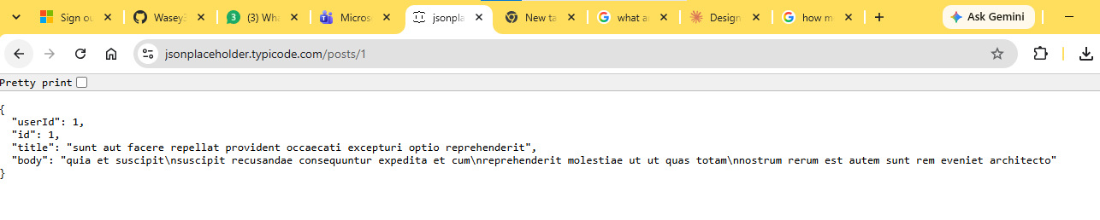

Then
Change the URL to:
https://jsonplaceholder.typicode.com/posts/2
and then:
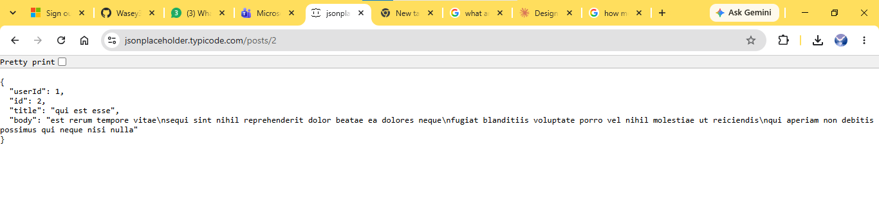
https://jsonplaceholder.typicode.com/posts/3
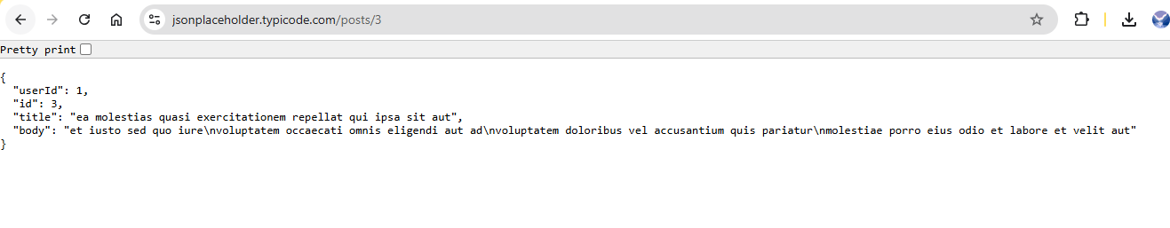

Answer
Write a short explanation of why the response changes when /1, /2, and /3 are used.
Each URL points to a unique record in the server's database, which is why the JSON output changes to show the title, body, and user ID corresponding to that specific post ID.

Evidence
☐ Screenshot of /posts/1
☐ Screenshot of /posts/2
☐ Screenshot of /posts/3
The activity directly follows the browser/API exercise in Phase 01.

Task 02 — Identify the Client, API and Server
Using the previous task, create a simple diagram showing:
Browser → API → Server → Response
Label each component.
Then write 3–5 sentences explaining what happens when the browser requests /posts/1.

Evidence
☐ Communication diagram
☐ Written explanation
Browser: -----------Google Chrome, where the user requests the URL /posts/1----------API https://jsonplaceholder.typicode.com/posts/1 — the endpoint used to request post data
---------Server: JSONP laceholder, which processes the request and retrieves the requested post------- Response: JSON data containing the post's userId, id, title, and body.

Task 03 — Identify API Resources
Using JSONPlaceholder, investigate the following:
/posts
/posts/1
/posts/2
For each endpoint, identify:
Endpoint | Resource | Specific Resource?
/posts | __posts________ | __________
/posts/1 | ___posts__ | ______yes , id =1____
/posts/2 | ____posts______ | _________yes , id =2_

PHASE 02 — HTTP Requests, Responses & REST

Task 04 — Analyze a URL
Analyze this URL:
https://api.example.com/students/101
Identify:
- Protocol
- Host
- Path
- Resource
- Resource identifier
Submit your answer in a table.
No. | Component | Answer
1 | Protocol | https
2 | Host | api.example.com
3 | Path | /students/101
4 | Resource | students
5 | Resource identifier | 101

The URL structure and endpoint concepts are explicitly covered in Phase 02.

Task 05 — Build a REST API Operation Table
Complete the following table.
Operation | HTTP Method | Endpoint
Retrieve all students | ___get___ | ___/students___
Create a student | ___post___ | ____/students__
Retrieve student 101 | ____get__ | ______/students/101
Update student 101 | _____put_ | ______/students/101
Delete student 101 | _____delete_ | ______/students/101
Then explain why different HTTP methods are used for different operations.
The expected method/resource relationship is based on GET, POST, PUT and DELETE in the provided material.

Task 06 — Test GET Requests
Using JSONPlaceholder:
- Send a GET request to /posts/1.

1. Request to /posts/1
- Endpoint: [https://jsonplaceholder.typicode.com/posts/1](https://jsonplaceholder.typicode.com/posts/1)
- HTTP Method: GET
- Status Code: 200 OK
- Response Body: {
- "userId": 1,
- "id": 1,
- "title": "sunt aut facere repellat provident occaecati excepturi optio reprehenderit",
- "body": "quia et suscipit\nsuscipit recusandae consequuntur expedita et cum\nreprehenderit molestiae ut ut quas totam\nnostrum rerum est autem sunt rem eveniet architecto"
- }

- Send a GET request to /posts/2.

2. Request to /posts/2
- Endpoint: [https://jsonplaceholder.typicode.com/posts/2](https://jsonplaceholder.typicode.com/posts/2)
- HTTP Method: GET
- Status Code: 200 OK
- Response Body:
{
"userId": 1,
"id": 2,
"title": "qui est esse",
"body": "est rerum tempore vitae\nsequi sint nihil reprehenderit dolor beatae ea dolores neque\nfugiat blanditiis voluptate porro vel nihil molestiae ut reiciendis\nqui aperiam non debitis possimus qui neque nisi nulla"
}

- Send a GET request to /posts/3.

3. Request to /posts/3
- Endpoint: [https://jsonplaceholder.typicode.com/posts/3](https://jsonplaceholder.typicode.com/posts/3)
- HTTP Method: GET
- Status Code: 200 OK
- Response Body:
{
"userId": 1,
"id": 3,
"title": "ea molestias quasi exercitationem repellat qui ipsa sit aut",
"body": "et iusto sed quo iure\nvoluptatem occaecati omnis eligendi aut ad\nvoluptatem doloribus vel accusantium quis pariatur\nmolestiae porro eius odio et labore et velit aut"
}
For each request record:
- Endpoint
- HTTP method
- Status code
- Response body

Evidence
☐ Three successful API requests
☐ Recorded status codes
☐ Response data

Task 07 — Test POST
Create a new post using a POST request.
Use a request body containing:
{
"title": "My API Lab",
"body": "Testing POST request",
"userId": 1
}
Record:
- HTTP method
- Endpoint
- Request body
- Response status code
- Response body
The task is based on the POST/create-resource example in Phase 02.
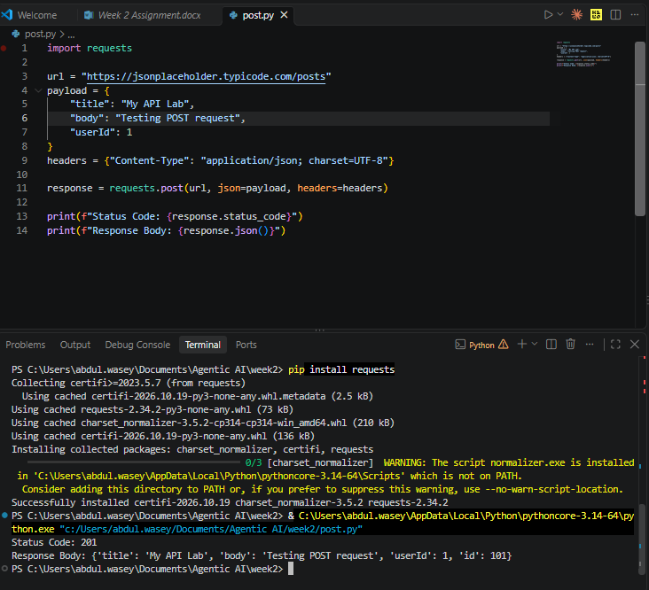

Task 08 — Test PUT
Update a resource using PUT.
Use:
PUT /posts/1
Create an updated JSON body.
Record:
- Request method
- Endpoint
- Request body
- Status code
- Response
The task is based on the PUT/update operation covered in Phase 02.
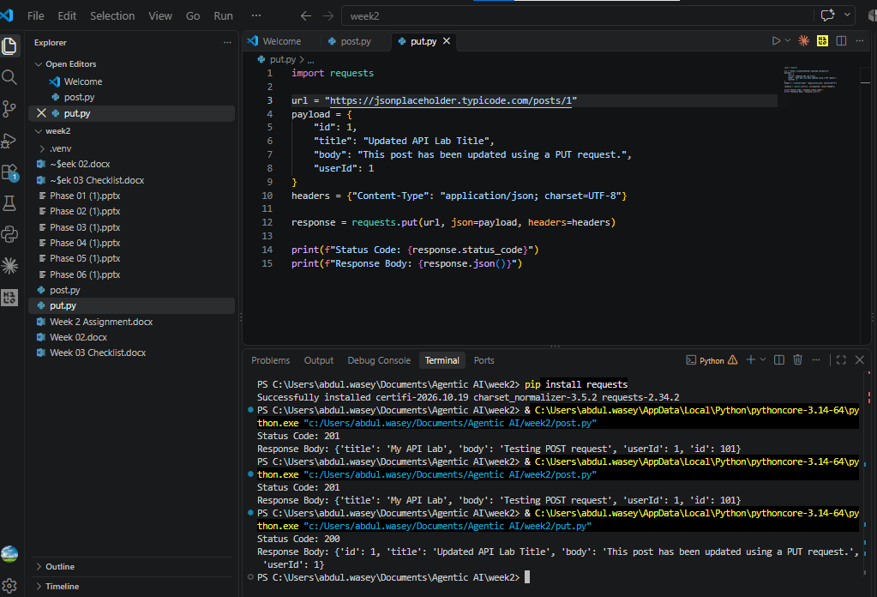

Task 09 — Test DELETE
Send:
DELETE /posts/1
Record:
- Request method
- Endpoint
- Status code
- Response
Explain what the DELETE operation is intended to accomplish.
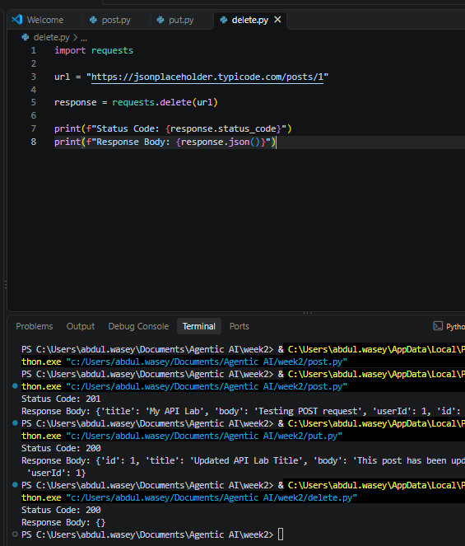

Task 10 — Investigate HTTP Status Codes
Perform requests that allow you to observe different HTTP status codes.
At minimum, investigate:
- 200
- 201
- 404
For each status code, record:
Status Code | Meaning | Your Test
200 | _____OK_____ | __________
201 | ________Created__ | __________
404 | _____not found_ | __________
Then explain the difference between a successful request and a resource-not-found response.
The supplied material explicitly distinguishes 2xx success and 404 resource-not-found behavior.

Difference Between a Successful Request and a Resource-Not-Found Response
- Successful Requests (2xx status codes like 200 and 201): These indicate that the server successfully understood, received, and processed the client's request. A 200 OK confirms that a standard operation (like retrieving or updating data) completed correctly, whereas a 201 Created specifically indicates that a POST request successfully resulted in the creation of a new resource.
- Resource-Not-Found Responses (404 status code): This is a client error response indicating that while the server is reachable, it cannot locate the specific resource or endpoint requested. This happens when a client queries an invalid path or a resource identifier (such as a database entry or post ID) that does not exist.

PHASE 03 — JSON & Python API Integration

Task 11 — Create a JSON Student Record
Create the following JSON object:
{
"name": "Ali",
"marks": 85,
"program": "BSCS"
}
Then create the equivalent Python dictionary.

Perform
- Store the data in a Python dictionary.
- Print the student's name.
- Print the student's marks.
- Print the student's program.
JSON objects and their conceptual mapping to Python dictionaries are covered in Phase 03.
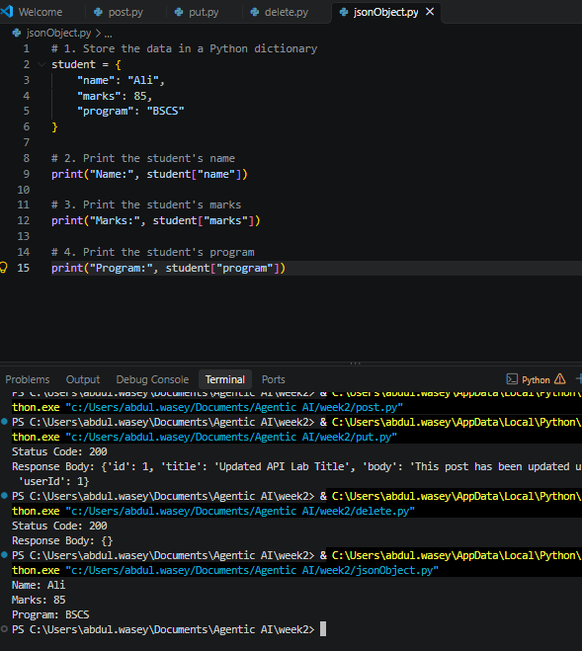

Task 12 — Work With a JSON Array
Create a JSON array containing at least three students.
Example structure:
[
{
"id": 1,
"name": "Ali"
},
{
"id": 2,
"name": "Sara"
}
]

Perform
Write Python code that:
- Stores the records in a list.
- Loops through all students.
- Prints each student's ID.
- Prints each student's name.
The supplied Phase 03 material specifically introduces JSON arrays as lists of dictionaries.
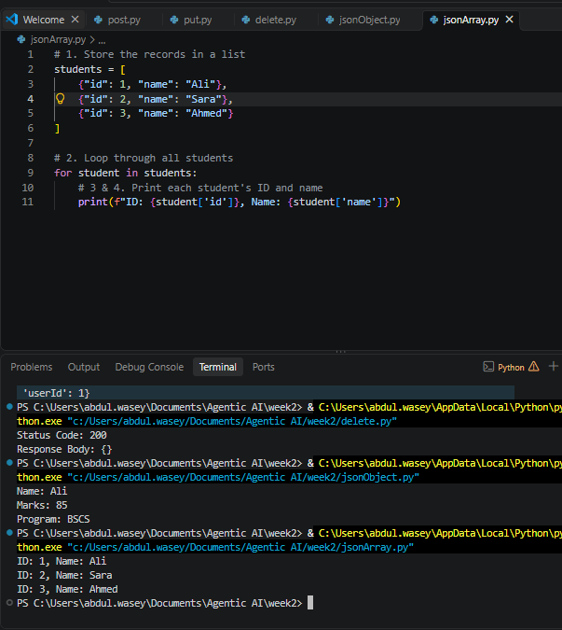

Task 13 — Create Your First Python API Client
Create a Python program that accesses:
https://jsonplaceholder.typicode.com/posts/1
Your program must:
- Send a GET request.
- Receive the response.
- Check the status code.
- Read the JSON response.
- Print the post ID.
- Print the post title.
- Print the post body.

Expected Output
Your terminal should display information similar to:
Status: 200
Post ID: 1
Title: ...
Body: ...

Evidence
☐ Python source code
☐ Terminal output
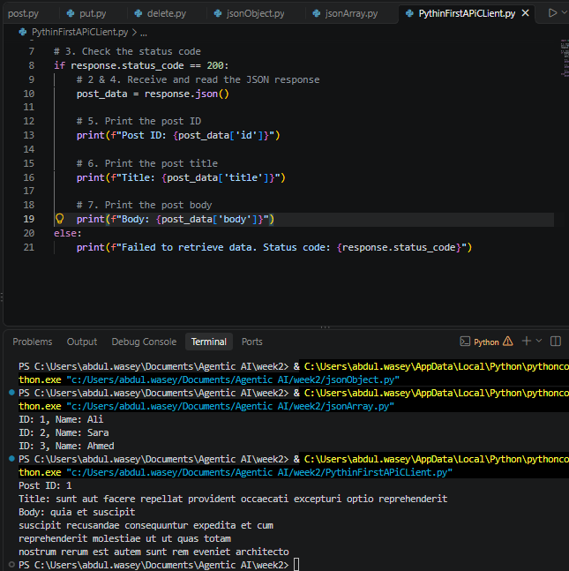

Task 14 — Retrieve Multiple API Records
Modify your Python program to retrieve:
/posts/1
/posts/2
/posts/3
Print:
Post 1: ...
Post 2: ...
Post 3: ...
Do not duplicate the complete program three times. Use appropriate Python logic.
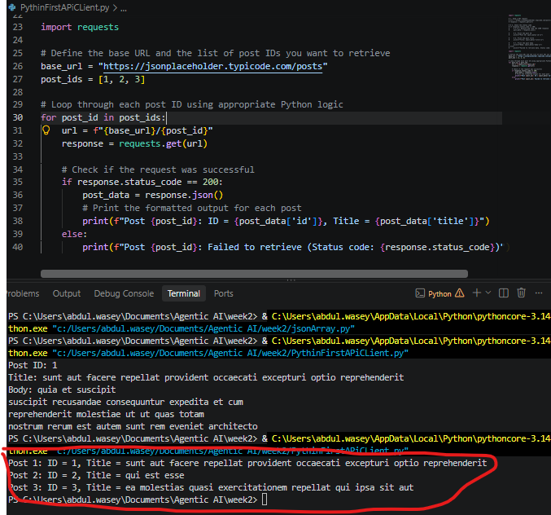

Task 15 — Retrieve and Process a Collection
Request:
https://jsonplaceholder.typicode.com/posts
Your program must:
- Retrieve the API response.
- Convert/process the JSON data.
- Determine the number of returned posts.
- Print the first five post titles.

Evidence
☐ Source code
☐ Terminal output
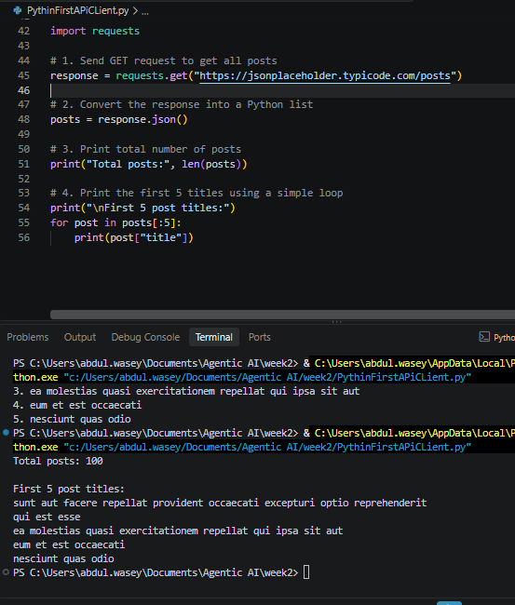

PHASE 04 — Authentication, API Keys & Secure Configuration

Task 16 — Public vs Protected API
Create a short comparison between a public API and a protected API.
Your comparison must include:
- Whether credentials are required
- Why authentication is used
- Example authentication mechanism
- What happens when credentials are invalid
The supplied material introduces public/protected APIs and API-key/token patterns.
A public API and a protected API differ fundamentally in accessibility and security requirements. A public API does not require credentials for basic access, allowing anyone to fetch data freely without authentication, Conversely, a protected API strictly requires credentials to ensure security, control access, and prevent unauthorized usage or data breaches by verifying who is making the request. To achieve this, a protected API typically relies on authentication mechanisms such as API keys passed in request headers, OAuth 2.0 bearer tokens, or JSON Web Tokens (JWT). When a user supplies invalid, expired, or missing credentials to a protected API, the server immediately rejects the request, returning an HTTP error status code (most commonly 401 Unauthorized or 403 Forbidden) alongside an explanatory error message, denying access to the requested resources.

Task 17 — Implement an Authorization Header
Create a Python request using an Authorization header following the pattern:
Authorization: Bearer TOKEN
Do not use a real credential in your submitted code.
Demonstrate that your program can construct the request headers correctly.

Evidence
☐ Python code
☐ Printed/sanitized request configuration
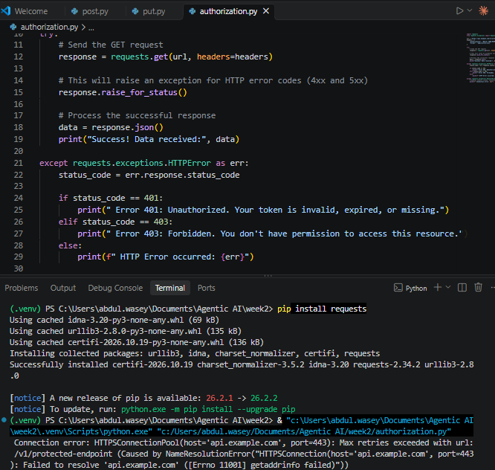

Task 18 — Move Credentials to .env
Create a .env file:
API_KEY=your_key_here
Then modify your Python program to obtain the value through an environment variable.
The source material specifically demonstrates .env and os.getenv() as the safer alternative to hardcoding credentials.

Requirements
☐ Create .env
☐ Store the API key in .env
☐ Load it using Python
☐ Do not write the key directly in the Python source
☐ Add .env to .gitignore
☐ Verify that the credential is excluded from version control

Important
Never submit your real API key to the instructor or Git repository.
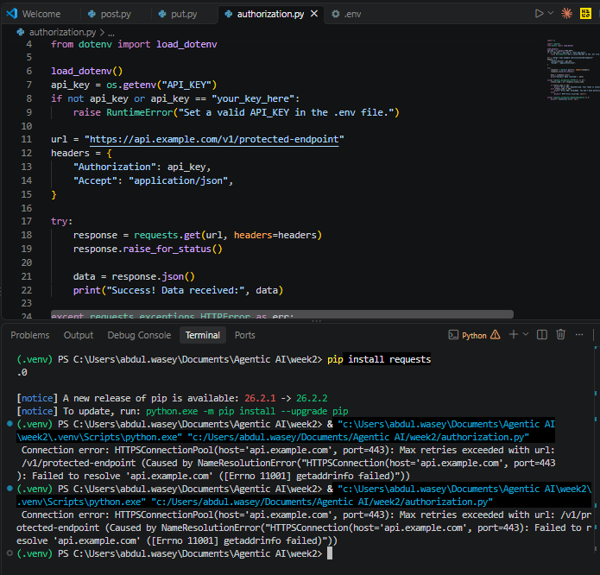

PHASE 05 — Errors, Timeouts & Rate Limits

Task 19 — Handle a 404 Error
Modify your Python API client so that it requests a resource that does not exist.
For example, request an invalid resource identifier.
Your program must:
- Send the request.
- Detect the 404.
- Print an appropriate error message.
- Continue/terminate gracefully without an unhandled exception.
The supplied material emphasizes that receiving an HTTP response does not mean the requested operation succeeded.

Expected behavior
Request failed.
Status Code: 404
Resource not found.
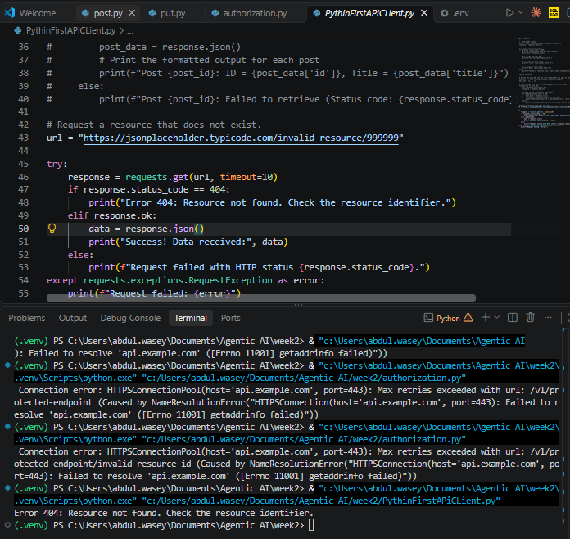

Task 20 — Handle Multiple HTTP Errors
Extend your program to distinguish between at least:
- Successful response
- 400
- 401
- 404
- 429
- 500
Create appropriate messages for each case.
Use the status-code categories provided in the lecture material rather than treating every failure identically.
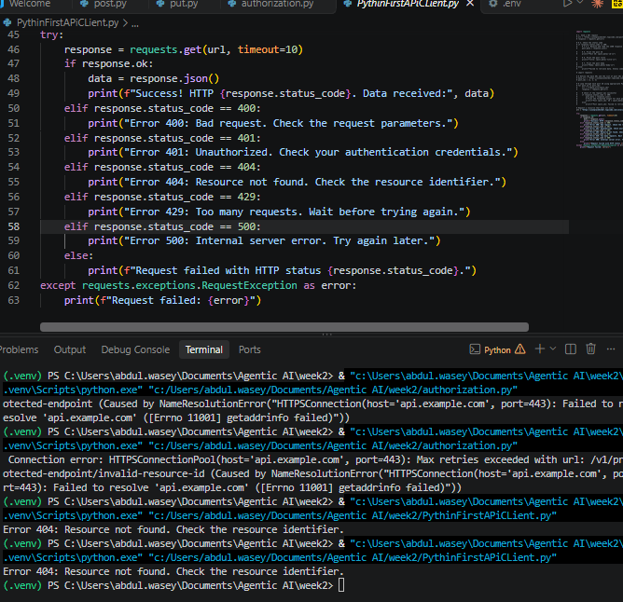

Task 21 — Add Request Timeout
Modify your API request so that it includes a timeout.
For example:
requests.get(
url,
timeout=10
)
Then:
- Explain why the timeout is necessary.
- Add timeout handling.
- Prevent the program from remaining indefinitely waiting for a response.
The Phase 05 material explicitly introduces the timeout parameter and its purpose.

Task 22 — Handle Network/API Failure
Modify your program so that it can gracefully handle a request failure.
Your program should distinguish between:
Successful request
API error
Timeout
Network/request failure
The supplied material identifies invalid requests, unauthorized requests, missing resources, rate limits, server failures, network failures and timeouts as possible API failures.

Task 23 — Investigate Rate Limiting
Research the concept of API rate limiting using the explanation provided in the lecture.
Answer:
- What is a rate limit?
- Why do APIs impose rate limits?
- What does HTTP 429 mean?
- Why can an automated program generate too many requests?
- Why is this especially important for agentic systems?
The supplied material explicitly connects repeated automated requests and rate limits with agentic systems.

PHASE 06 — From API Integration to Agent Tools
The supplied Phase 06 material only establishes the transition from API integration to agent tools. Therefore, these tasks should be treated as a practical transition exercise rather than as material directly specified in the slides.

Task 24 — Define an API Tool
Select one API operation you implemented in the previous phases.
Create a tool specification containing:
Tool Name:
Description:
HTTP Method:
Endpoint:
Required Inputs:
Optional Inputs:
Expected Output:
Possible Errors:
Authentication Required:
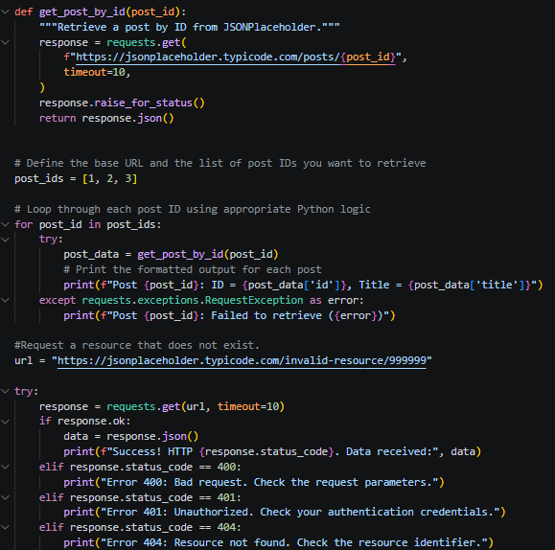

Task 25 — Design an Agent Tool Interface
Convert your selected API operation into an agent-oriented tool definition.
For example:
Tool: get_post
Purpose:
Retrieve a post using its ID.
Input:
post_id
Output:
id
title
body
userId
Possible Errors:
404
429
500
Timeout
Do not build an AI agent yet. The objective is to understand how an API operation can be represented as a tool.
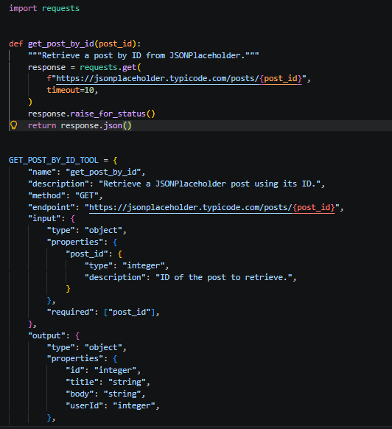

FINAL INTEGRATION PROJECT

Task 26 — Build a Complete API Client
Create a small Python application that demonstrates everything learned in Phases 01–05.
Your application must:

API Communication
☐ Connect to an API.
☐ Use an appropriate HTTP method.
☐ Use a valid endpoint.
☐ Send the request.

JSON Processing
☐ Receive JSON.
☐ Parse/process the JSON.
☐ Extract selected fields.
☐ Display useful information.

Authentication
☐ Demonstrate authentication if the selected API requires it.
☐ Do not hardcode credentials.
☐ Use environment variables for credentials.

Error Handling
☐ Check HTTP status codes.
☐ Handle 404.
☐ Handle authentication failure where applicable.
☐ Handle request/network failure.
☐ Handle timeout.
☐ Consider rate limiting.

Documentation
☐ Document the API endpoint.
☐ Document the HTTP method.
☐ Document required parameters.
☐ Document request body, if applicable.
☐ Document response structure.
☐ Document possible errors.
☐ Explain how the API operation could later become an agent tool.

FINAL DELIVERABLE
Submit a folder containing:
API-Lab/
│
├── phase01/
│
├── phase02/
│
├── phase03/
│ └── api_client.py
│
├── phase04/
│ ├── api_client.py
│ ├── .env.example
│ └── .gitignore
│
├── phase05/
│ └── api_client.py
│
├── phase06/
│ └── tool_specification.md
│
├── final_project/
│ ├── src/
│ ├── README.md
│ └── requirements.txt
│
└── evidence/
├── task01.png
├── task06.png
├── task07.png
├── task13.png
├── task18.png
├── task19.png
└── ...

